

A Project Report On

**ATM Interface**

**By**

**J.Priya**

**Batch:** 2022 – 7905

**Center: Trichy Thillainagar**

Under the Guidance of

**Chittaranjan Ghosh.**

**Technical Trainer**

**EduBridge**

## Introduction:

An Automated Teller Machine (ATM) Interface System allows customer to perform banking transaction anywhere at anytime without the need of human teller. By using ATM card at an ATM, individuals can withdraw cash from saving accounts. To make a deposit or transfer money from one account to another and perform other functions also.

**Modules:-**

* User Module

I have developed this Application in **Java and MySQL.** This project is a console based application.

The main objective of the ATM Interface System is to reduce manual work and time. It is difficult and time-consuming to transect our money from each branch bank account. To avoid this problem, we use ATM Machine . In our user module first the user will insert the ATM card in the ATM machine. Then the ATM will ask for Personal Identification Number(PIN).

If the number is entered incorrectly most ATMs will retain the card for security precaution. Once the correct pin is given the ATM ask some perfume about account.

If you want to know the account balance you perform the balance check task, it will give the current balance.

If you want to withdraw amount, you can move that option. After then the ATM will ask for the amount of money to be withdrawn. If account haven’t contain that much of money, the insufficient balance message will display.

If you want to deposit some money, you can choose deposit option. ATM ask some amount of money with deposit process, after the completion that amount will add in your account. You can perform more options and access some bank details as per ATM machine versions.

**Software Requirements:**

**Back end**: MySQL workbench 8.0 CE, JAVA jdk version 19

**Text Editor:** Eclipse IDE for Java Developers

**Browser:** Best result on Google Chrome

**Operating System:** Windows 10

# Data Dictionary:

**Create Database ATM Users:**

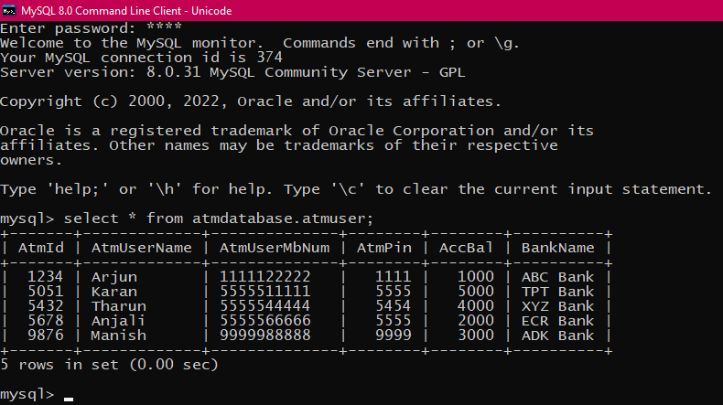

**After Withdraw Database:**

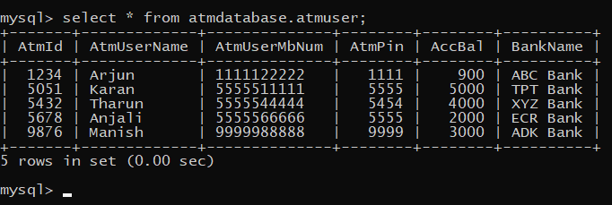

**After Deposit Database:**

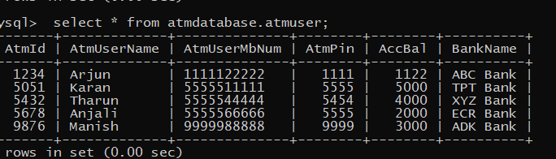

**ATM process Database:**

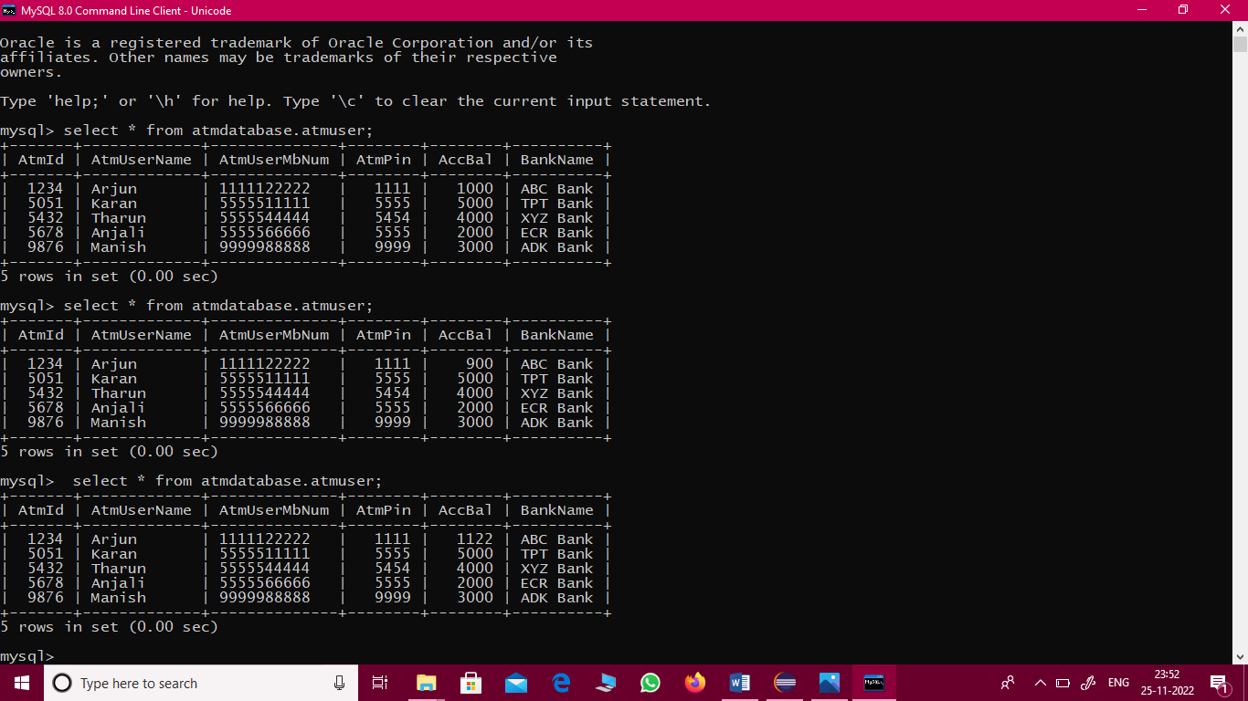

# Console Screenshots:-

## Interface without input:

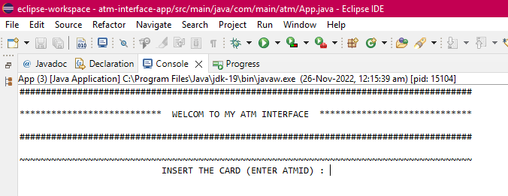

**Display after enter PIN:**

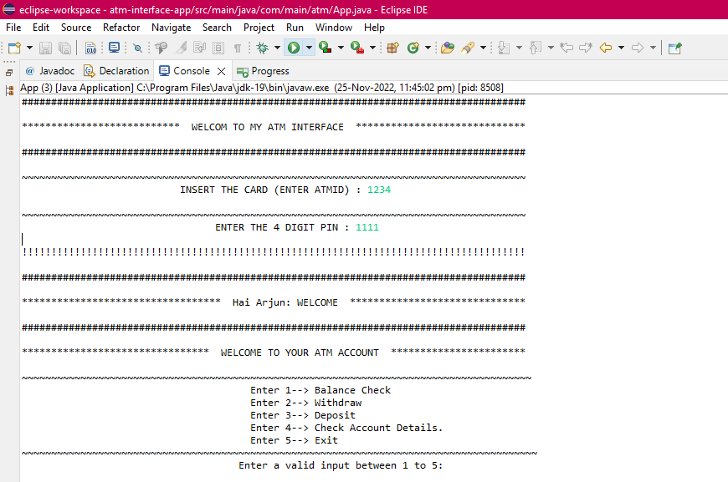

**Balance Checking:**

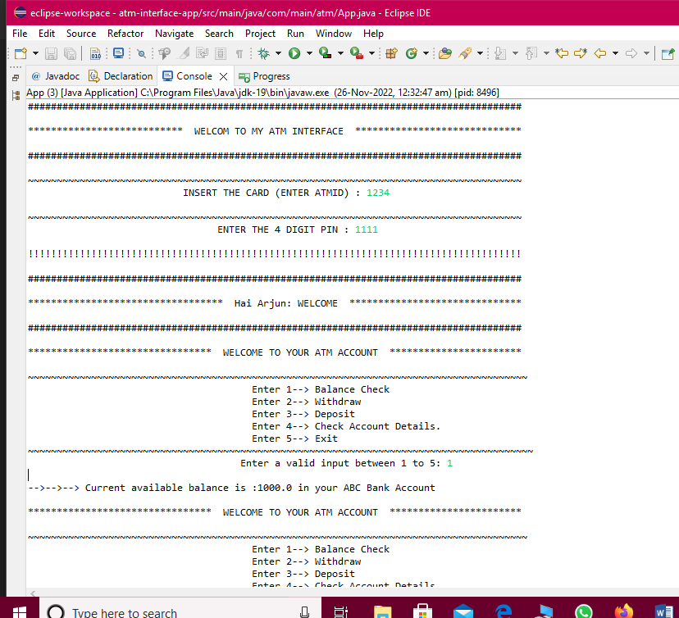

**Withdraw process:**

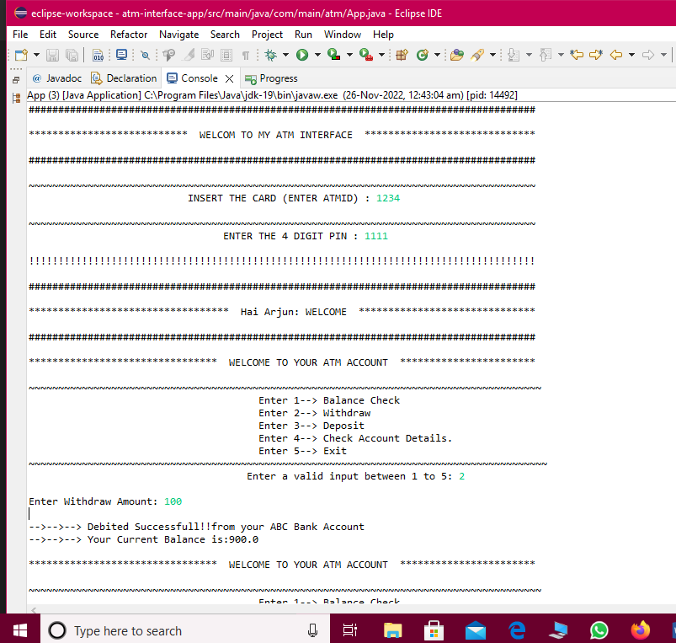

**Deposit process:**

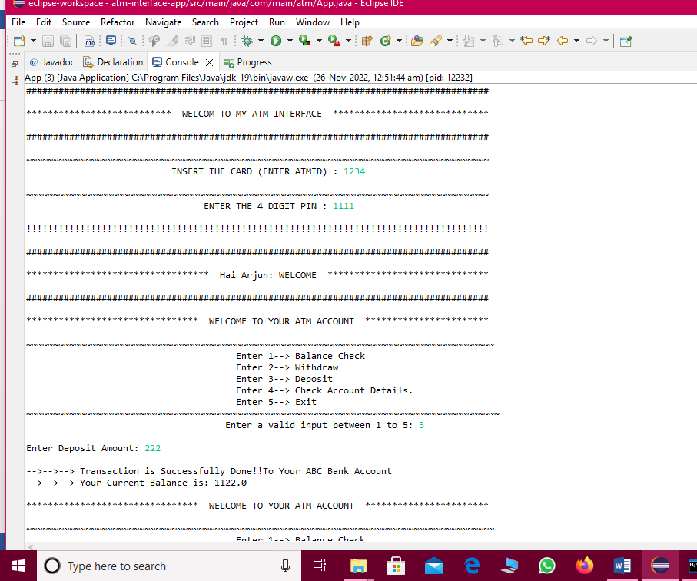

**Withdraw and deposit in one operation:**

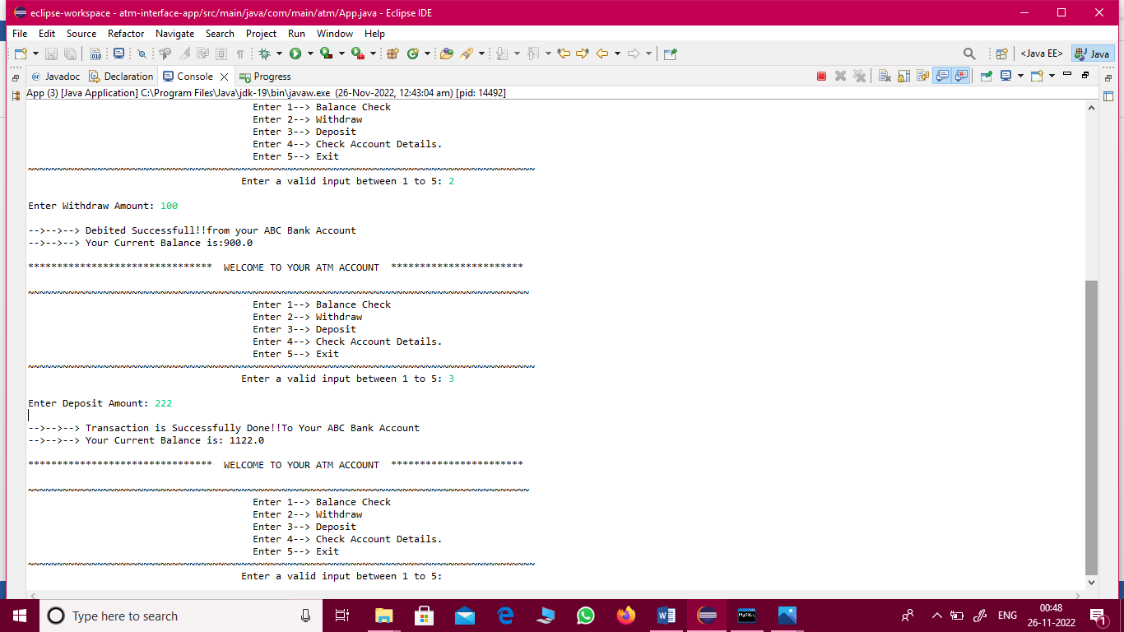

**ATM user details:**

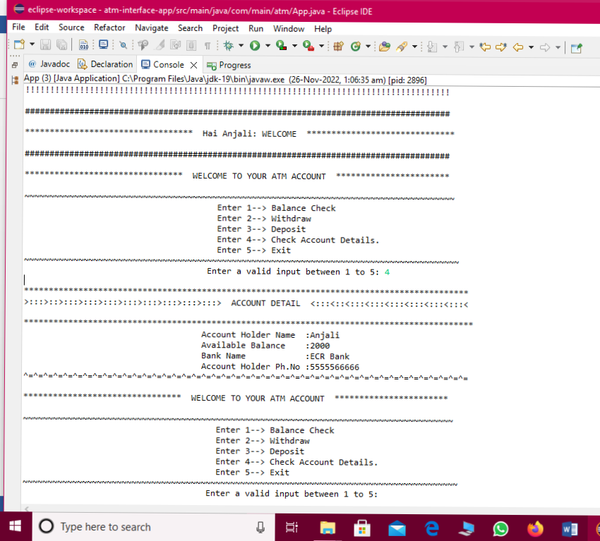

**Wrong PIN :**

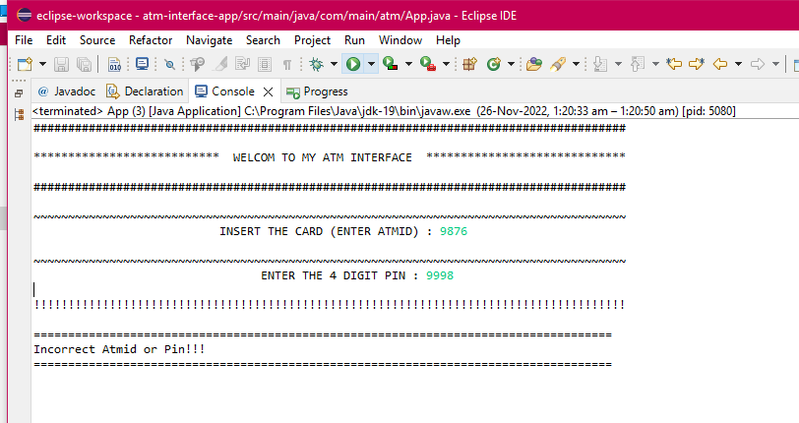

**Wrong Input:**

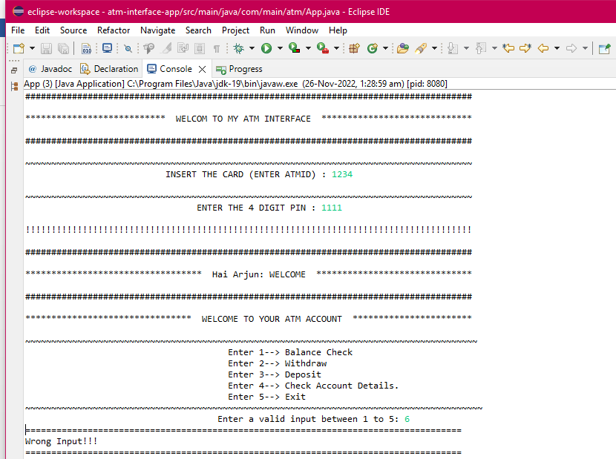

**EXIT:**

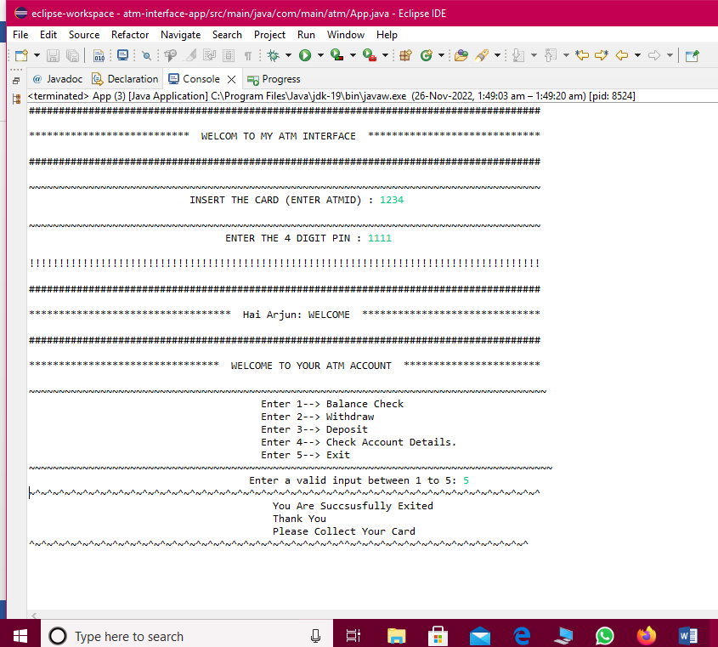

**Thank you….**

**Suggestions?.....**